Ecosystem Dynamics: Habitats, Niches & Species Interactions Name: _______________________
(Read Ch.22.1; pgs. 667-673)

- How would you describe the habitat in which an organism lives?
An area with a particular combination of physical and biological environmental factors that affect
which oragnism can live within it.

- Define tolerance? The variety of environmental conditions within which the organism can survive and reproduce
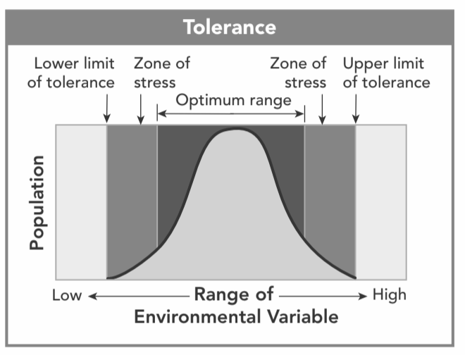
- Looking at figure 22-2 to the right (as seen in the text). Define optimum/ optimal in your own words. The BEST conditions (to survive, grow and reproduce)

- What does it mean for an organism to be in a “Zone of Stress”?
The one or more environmental conditions is NOT optimal
What does being in this zone lead to?
The organism will need to expend (use) more energy to survive and that leaves less energy for growth and reproduction.

- Define Niche: Describes where an organism lives and WHAT IT DOES (it’s role), including the way it interacts with BIOTIC and ABIOTIC factors.

- There are 2 aspects that go into determining an organism's niche. Use the table below to define and give an example of each aspect.
 | Define | Example from our Chaparral Ecosystem
Physical Aspect of Niche | The abiotic factors to which the organism is adapted. | Temperature is seasonal. It is also warm during the day and cool at night.
Biological Aspect of Niche | The biotic factors the organism requires for survival. | Animals like a jackrabbit have short fur to not overheat, but enough to stay warm. They have large ears to let off excess heat

- Explain why no two species can occupy the same niche at the same time.
Competition will occur for whatever that resource is that becomes limited. When this occurs the
competitive exclusion principle is in effect and the more competitively successful species will
outcompete the other.

- Why are predator-prey and herbivore-plant relationships important in shaping communities?
These relationships often affect the population sizes of not just predators, prey, and plants, but also
other species in the community. For example, more prey being killed and then left partially eaten by
the predators provides more food for many different scavengers and then eventually decomposers
which then affects nutrients for plants.

- What is a sea otter's niche (biologically)? Sea otters eat sea urchins and eat enough to control the urchin population.

- What happens when sea otters are removed from their ecosystem? When sea otters are removed, urchin populations increased and the kelp forests vanished. Without kelp forests as a habitat many fish and seabirds disappeared from these areas as well.
- What is a keystone species? It is a species that plays a vital and unique role in maintaining structure, stability, and diversity in an ecosystem.

- Complete the sentence by circling one of the bold words:
The presence of a keystone species (increases or decreases) the ecosystem’s biodiversity (amount of species variety).

- What is symbiosis? A particularly close, interdependent relationship between two species

- Use the table below to list, describe & give an example of each:

Type of Symbiosis | Definition | Example of Relationship  Give your own example
Commensalism | A relationship in which one species benefits and the other is neither helped nor harmed.  (+/0) | Little mites that live in our house. They benefit with food from us and we are not helped nor harmed.
Mutualism | A relationship between 2 species where BOTH species benefit.  (+/+) | Bacteria that live in the stomachs of termites.
Parasitism | A relationship in which one organism lives inside or on another organism and harms it.  (+/-) | Lamprey fish that attach to other fish and suck nutrients which harms the host fish

